Design document for the   
computer game *Helicopterz*

# Game description

In the game, *Helicopterz*, the user controls a helicopter that moves up and down through a maze of blocks. The goal of the user is to last as long as possible without touching any obstacles or walls during their run. If the user reaches five thousand points, they ‘win’ the game. The game is simple in nature but increasingly difficult as blocks begin to spawn in the middle of the track and the game begins moving faster. The helicopter is affected by gravity and only moves up while the user is holding the space bar. Helicopter game is very simplistic in design to allow the user to focus on his/her model. The game was inspired by the original version from 2000, and many design choices down to the green blocks and solid colored background are inspired by this version. However, the added feature is the difficulty menu. The user can select ‘easy’, ‘medium’ or ‘hard’ difficulty. Medium will increase the starting and highest possible speed from the easy values. However, hard will increase the starting and highest possible speeds even more along with ‘added challenge’. The added challenge is that walls spawn on the top and bottom of the screen with holes in the middle. Now, the user must aim for the holes to survive. Upon losing or quitting, the game will display a special animation/screen depending on the reason that the game ended. *Helicopterz* aims to provide the user with a relaxing yet challenging game that anyone can play regardless of age or preferences.

# Instructions for playing the game.

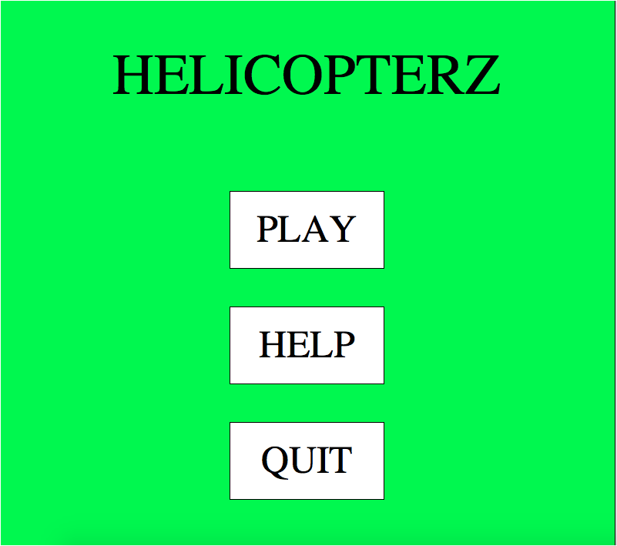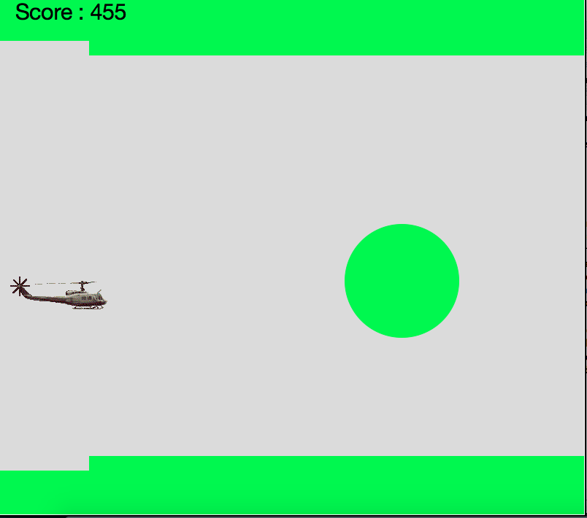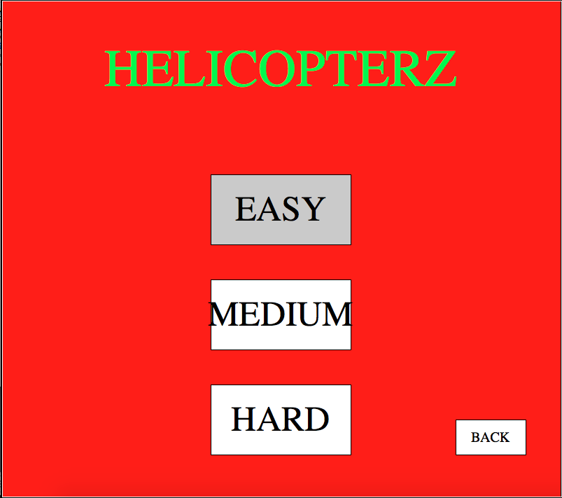  
First, the user must open the game program called ‘Heli_Game.py’. They must open it in idle. Once the program is open, in idle, the user can click ‘f5’ to run the game. The game starts off on the menu screen. The user can navigate the menu screen with their mouse. When they mouse over a button, they can click on it, with <mouse button-1> to activate the button’s properties. If they click the ‘play’ button, they will enter the difficulty menu. In the difficulty menu, the user can choose either ‘easy’, ‘medium’ or ‘hard’ difficulty. They can choose again by clicking with their left click button. If the user selected help from the main menu, the game will display instruction on how to play the objective of the game. On both the difficulty and help screen, there is a back button that will take them back to the original menu. There is also a quit button on the main menu screen that, when pushed, will destroy the game window. In game, there are two commands, movement and to quit. Movement is controlled by the space bar. Pushing the space bar will move the helicopter up but when you release the key, it will drop the helicopter at the same speed at which the helicopter was raised. The ‘Q’ key, quits the game. It will raise a quit screen with text and end the window.